Suzuki Cymru Summer Workshop 2020

Join Suzuki Cymru on our Summer Camp 4 day workshop on Thursday 25th - Sunday 28th of July. The course is suitable for pianists of all ages and abilities and will be held at RAF St Athan in the Vale of Glamorgan. The aim of the course is to inspire pianists of all levels and to motivate further development through a range of activities designed to supplement learning and also to help children grow in confidence. For further information about the teachers and experiences on offer please visit www.suzukicymru.co.uk.

Learning Opportunities
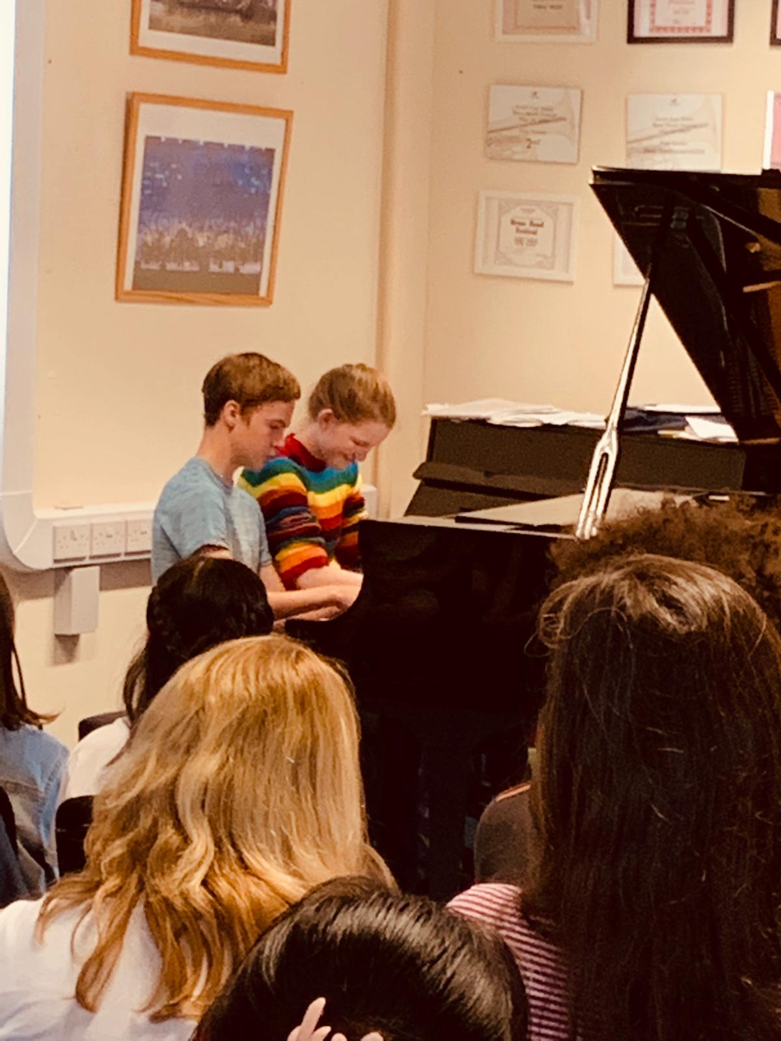
Participants will receive an individual lesson with exceptional Suzuki practitioners to develop their own personal playing technique, a group lesson helping children to gain ensemble experience through familiar Suzuki repertoire and Jazz Improvisation. In addition, we will also be offering a chance for each child to perform as part of a Chamber music ensemble, children playing books 1 & 2 will play their Suzuki repertoire and children in later books may select their own ensemble piece or play a Suzuki piece if they wish. The course will culminate with a concert on the Sunday afternoon. Children will also perform a solo piano piece in a platform concert and for those children who play a second instrument or wish to present a duet we can feature their talents in this area too.
Family Fun
The price includes all teaching and activities during the day, breakfast for campers, lunch, snacks and tea, coffee and drinks throughout the course. Additional family members are very welcome; there is plenty to do in the area during the day exploring the South Wales Coastline. Alternatively, Cardiff is easily accessible for excursions. Evening activities are planned such as Bowling and pizza or Fish and Chips on the beach to ensure that the fun continues after the teaching stops.
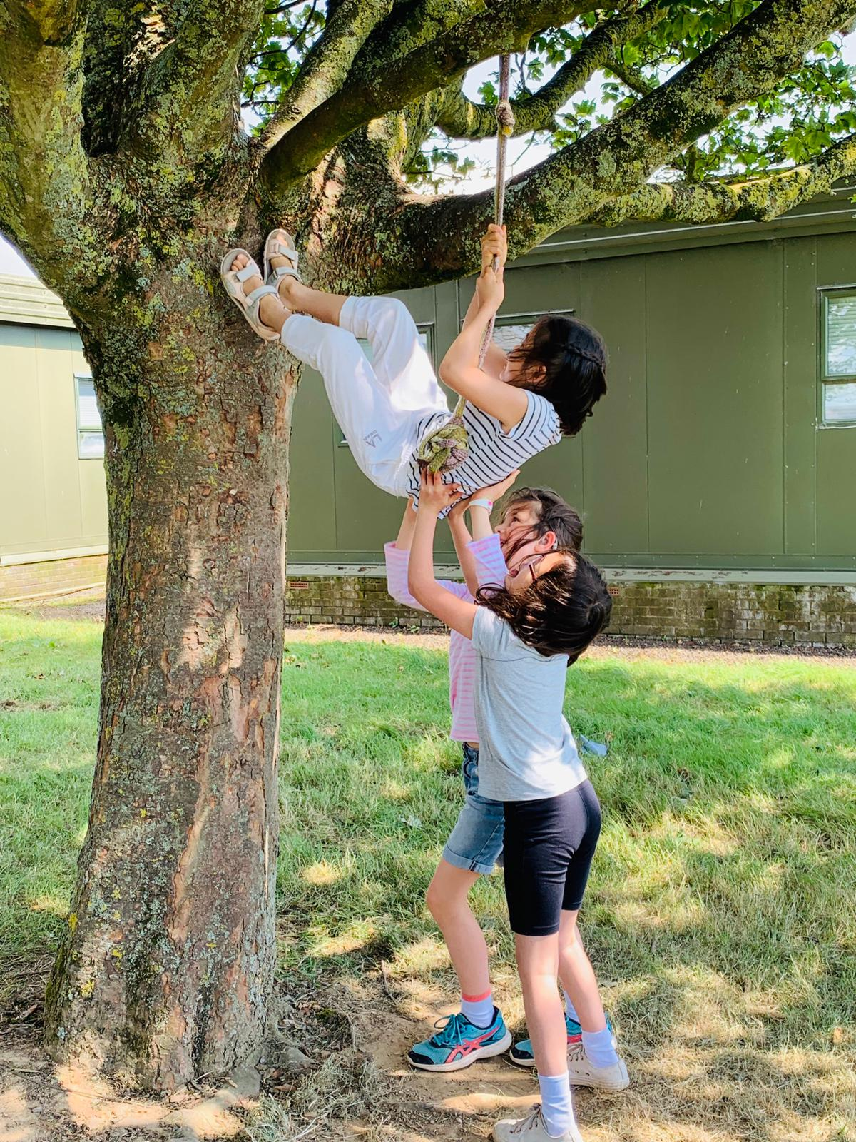
Accommodation
The course is situated just 6 miles from Cardiff Wales Airport and 1 mile from Llantwit Major Station. We can arrange lifts for those families wishing to join us by air or rail. For those who prefer their creature comforts, there are multiple nearby budget friendly hotels. You will need to book your own accommodation – book early to secure the cheapest prices. The more adventurous families are invited to bring a tent, caravan or motorhome and camp at Happy Jakes camping site just a short drive away. The campsite is very well equipped with showers, electric points and even a playground for the children. Happy Jakes can get very busy and early booking is recommended, speak to Mandy Edwards at 01446750174. www.happyjakes.co.uk
Suzuki Cymru Summer Workshop
23rd July – 26th July 2020

Send completed forms to cbstathan@gmail.com or
Claire Bourne, 2 Warlow Close, St Athan, Vale of Glamorgan CF62 4LT.
Accompanying parent’s details:
Name of parent(s) attending the course: | *British Suzuki Institute (BSI) number:
Hometown/City: | Email:
Piano Teacher: | Teacher Email:
Method of travel: Air/Rail/Car  delete as applicable | Accommodation:  Camping/hotel/other delete as applicable  If you require help finding accommodation please get in touch.

Participating child details:
Child 1
First Name: | Surname: | Age in July 2020
Latest Piece – book 1 pianists please state whether hands together

Child 2
First Name: | Surname: | Age in July 2020
Latest Piece – book 1 pianists please state whether hands together

Allergies: If you or your child has a serious allergy or would like to follow a particular diet such as vegan/GF/Diary-free please give details in the table below.

If you child has any additional learning needs please email in confidence.

Cost | Names: please write the names of each attendee in each category | Food requirements | £
Participating Child £230
Accompanying Adults £50
Non playing children free
Total

Payment:
BACS; Account Name: Suzuki Cymru, S/C: 30-67-34, A/C: 75724360.
Please send payment confirmation to cbstathan@gmail.com or cheque to “Suzuki Cymru”.
Please pay a non returnable deposit of £100 per family to secure your place. Balance to be paid by 30th June 2020 The course will run between 10.00am on the first day and 4.00pm on the final day. Please be aware that by attending the Suzuki Cymru Summer Workshop you are giving permission for photographs and videos to be taken and used for promotional purposes. For further details please see our website www.suzukicymru.co.uk*All participants must be members of the British Suzuki Institute or other national Suzuki Association for international participants.
Additional accommodation (B&B, boutique hotels) is available in Llantwit Major, Cowbridge and Barry has a Travelodge and Premier Inn.

