Suzuki Cymru Summer Workshop 2019

Join Suzuki Cymru on our Summer Camp 4 day workshop on Thursday 25th - Sunday 28th of July. The course is suitable for pianists of all ages and abilities and will be held at RAF St Athan in the Vale of Glamorgan. The aim of the course is to inspire pianists of all levels and to motivate their further development through a range of activities designed to supplement their learning and also to help them grow in confidence. For further information about the teachers and experiences on offer please visit www.suzukicymru.co.uk.

Learning Opportunities
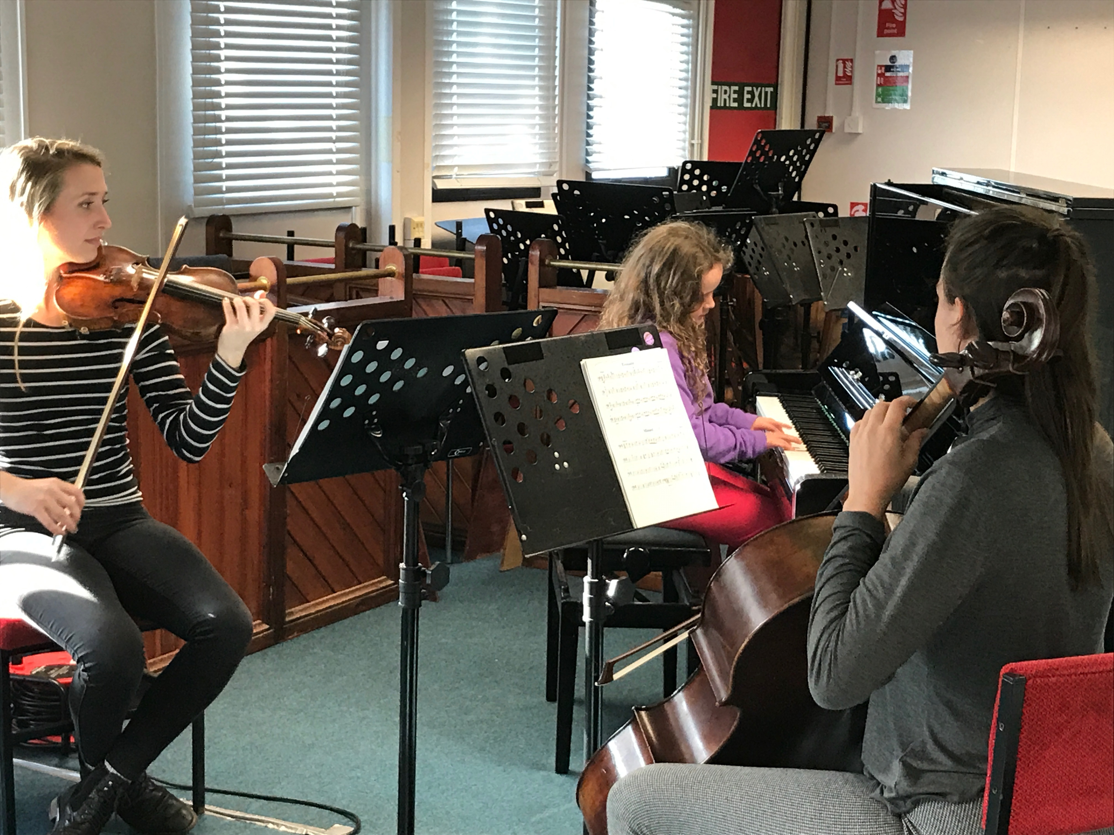
Participants will receive an individual lesson with an exceptional Suzuki practitioner to develop their own personal playing technique, a group lesson helping children to gain ensemble experience through familiar Suzuki repertoire and Jazz Improvisation. In addition, music enrichment opportunities, which will be matched to the age and developmental needs of the children. We will also be offering a chance for each child to perform as part of a Chamber music ensemble, children playing books 1 & 2 will play their Suzuki repertoire and children in later books may select their own ensemble piece or play a Suzuki piece if they wish. The course will culminate with a concert on the Sunday afternoon.
Family Fun
Evening activities are planned to allow for outdoor games for the children to participate in whilst the adults have the opportunity to unwind and relax. The price includes breakfast for campers, a picnic lunch, evening meals and tea, coffee and drinks throughout the course. Additional family members will be made very welcome; there is plenty to do in the area during the day exploring the South Wales Coastline. Alternatively, Cardiff is easily accessible for excursions.

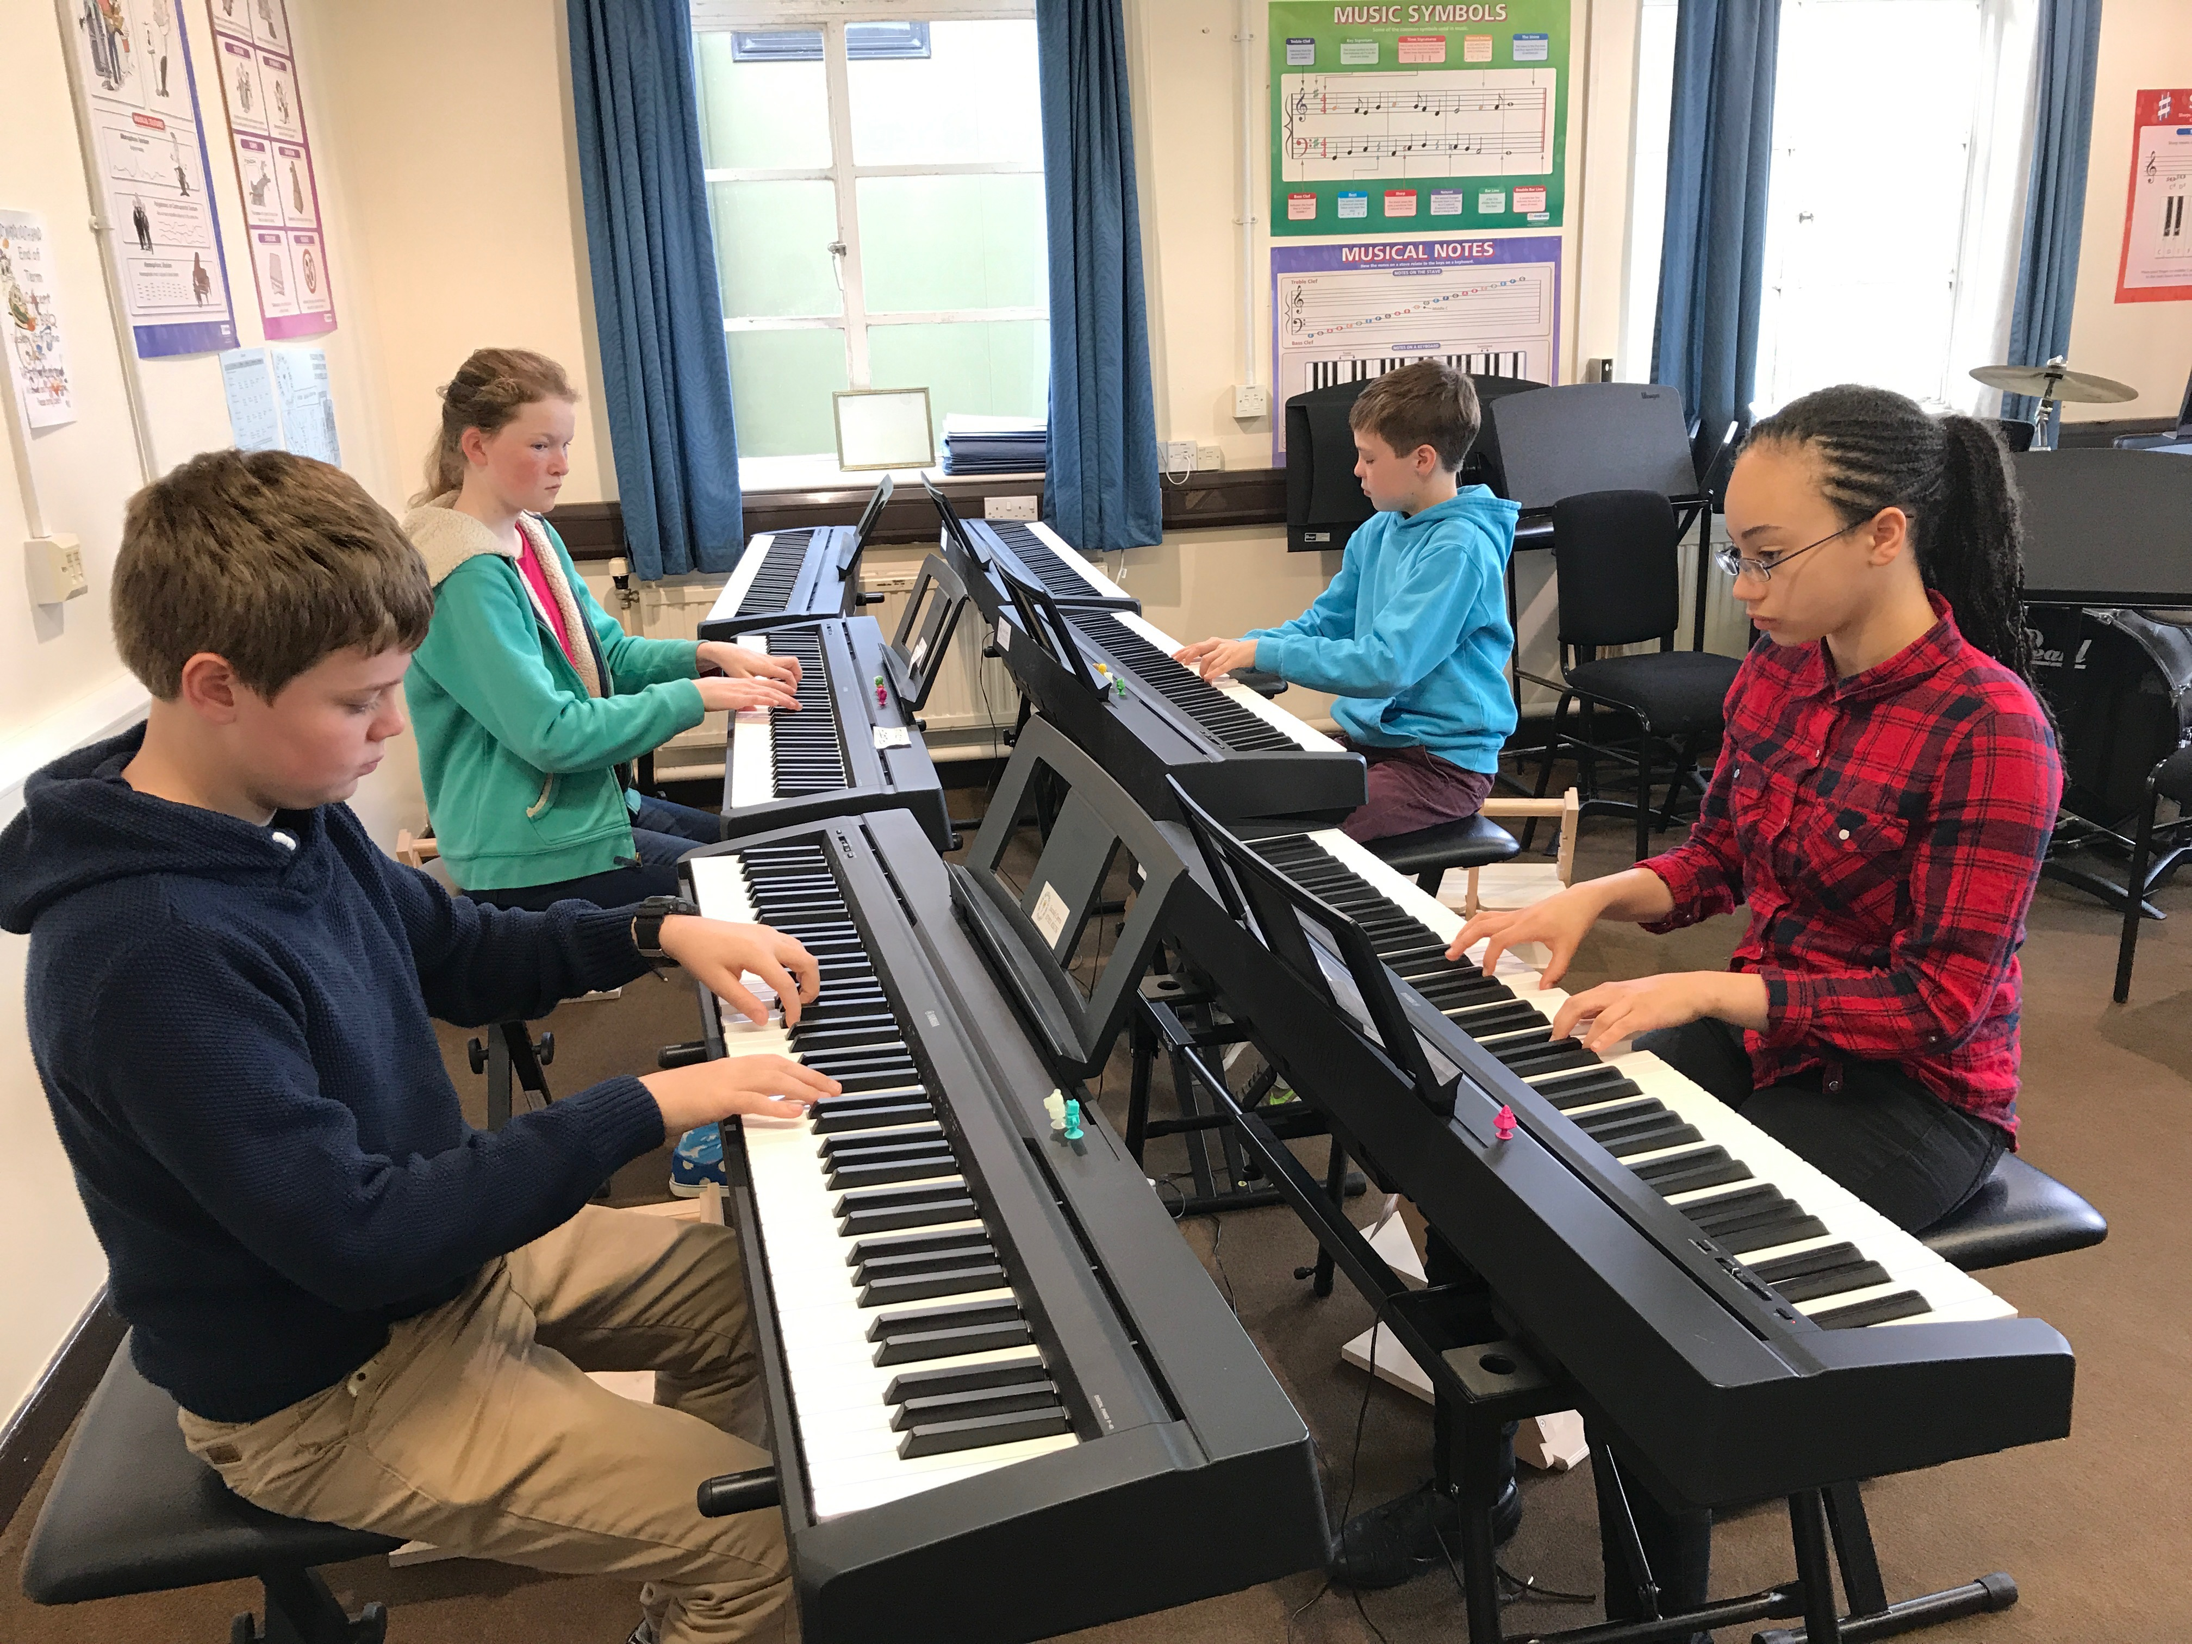
Accommodation
The course is situated just 6 miles from Cardiff Wales Airport and 1 mile from Llantwit Major Station. We can arrange lifts for those families wishing to join us by air or rail. For those who prefer their creature comforts, there is a Holiday Inn Express at Cardiff Airport offering family rooms at a very reasonable price. You will need to book your own accommodation – the earlier the better to secure the cheapest prices. The more adventurous families are invited to bring a tent and camp at Happy Jakes camping site just a short drive away. The campsite is very well equipped with showers, electric points and even a playground for the children. Caravans and Motorhomes are also welcome. Happy Jakes can get very busy and early booking is recommended, speak to Mandy Edwards at 01446750174. www.happyjakes.co.uk
Suzuki Cymru Summer Workshop
25th July – 28th July 2019

Send completed forms to cbstathan@gmail.com or
Claire Bourne, 2 Warlow Close, St Athan, Vale of Glamorgan CF62 4LT.

Accompanying parent’s details:
Name of parent(s) attending the course: | *British Suzuki Institute (BSI) number:
Hometown/City: | Email:
Piano Teacher: | Teacher Email:
Method of travel: Air/Rail/Car delete as applicable | Accommodation:  Camping/hotel/other delete as applicable  If you require help finding accommodation please get in touch.

Participating child details:
Child 1:
First Name: | Surname: | Age in July:
Book: Piece:

Book 1 pianists please specify which pieces hands together
Child 2:
First Name: | Surname: | Age in July:
Book: Piece:

Book 1 pianists please specify which pieces hands together

Allergies: If you or your child has a serious food allergy please include details here:
If you or your child is vegetarian/vegan please give details here:

If you child has any additional learning needs please email in confidence.

Cost | Names: please write the names of each attendee in each category | £
Participating Child £225
Accompanying Adults £65
Non playing children free
Total

Payment:
BACS; Account Name: Suzuki Cymru, S/C: 30-67-34, A/C: 75724360.
Please send payment confirmation to cbstathan@gmail.com
Or
Cheque payable to “Suzuki Cymru”.

Please pay a deposit of £100 per family to secure your place. Balance to be paid by 30th June 2019 The course will run between 11.00am on the first day and 4.00pm on the final day. Please be aware that by attending the Suzuki Cymru Summer Workshop you are giving permission for photographs and videos to be taken and used for promotional purposes. For further details please see our website www.suzukicymru.co.uk
*All participants must be members of the British Suzuki Institute or other national Suzuki Association for international participants.
Additional accommodation (B&B, boutique hotels) is available in Llantwit Major, Cowbridge and Barry has a Travelodge and Premier Inn.

